**Project Report – Sequence2Sequence**

## **Title: Sequence to Sequence Learning with Neural Networks**

## **Reference:**

Sutskever, Ilya, Oriol Vinyals, and Quoc V. Le. "Sequence to sequence learning with neural networks." *Advances in neural information processing systems*. 2014.

## **Motivation:**

This paper refers to the problem of machine translation, i.e. translating sentences from one language to another using machine learning, and in this case specifically using a multilayered LSTM neural network.

## **Short description:**

The algorithm was designed to receive a sequence of words in some language and output the translated sequence in a target language. Each word was embedded to a 1000-dimensional vector, before passing as an input to the network. The network consisted of 4 layers – 2 layers for encoding the input sequence, and 2 layers decoding the output sequence. Also, the authors stated that reversing the order of the input had an extremely positive influence on the results, so we did the same.

The article tested translated from English to French, and we decided to translate from English to Hebrew instead.

## **Architecture:**

As stated above, this paper used a 4 layers LSTM network, with a 1000-dimensional embedding in order to translate a sentence from one language to another. In order for our training process to end in feasible time, we used an embedding size of 64, and calculated the validation score every 250 iterations. In addition, SGD did not get as good results at all, so we decided to use Adam instead. .This architecture can be examined in the following diagram:

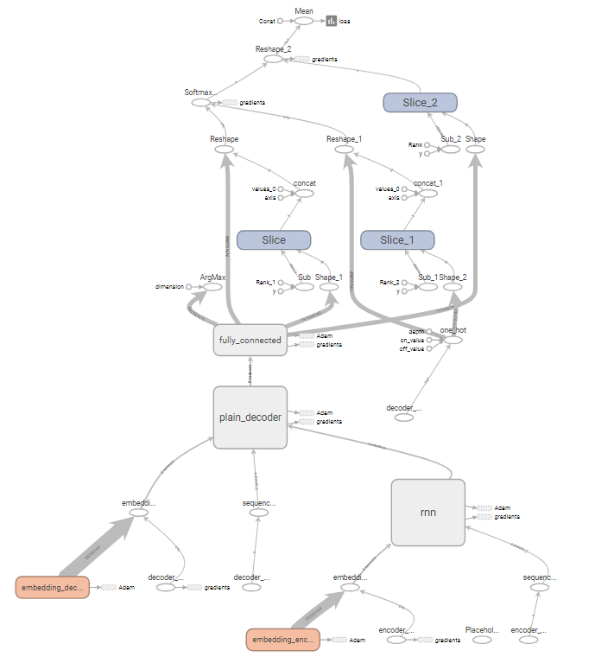

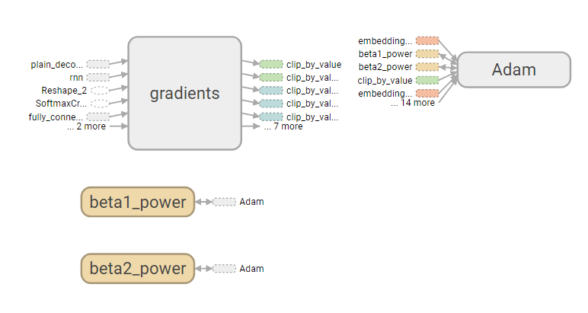

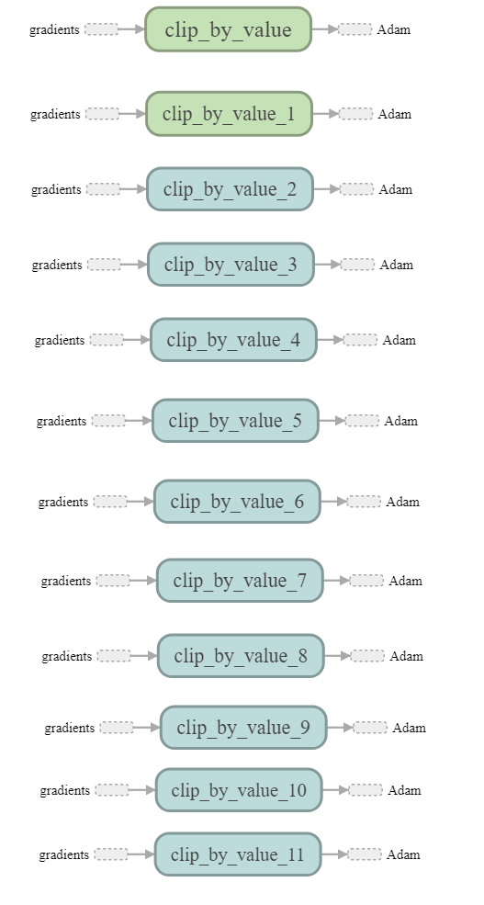

**Hyper-parameters:**

|  |  |  |
| --- | --- | --- |
|  | **Paper Original Values** | **Our Implementation Values** |
| **Initial learning rate** | 0.7 | 0.7 |
| **learning rate decline** | After 5 epochs, begin halving the learning rate every half epoch. | After 5 epochs, begin halving the learning rate every epoch. |
| **Non-linear functions** | Did not state | ReLu |
| **Loss function** | Categorical cross entropy | Categorical cross entropy |
| **# of epochs** | 7.5 | 25 |
| **Batch size** | 128 | 128 |
| **Embedding size** | 1000 | 64 |
| **Parameters initialization** | [-0.08 , 0.08] | [-0.08 , 0.08] |
| **Validation while training** | None | 20% of the training data was used for validation |
| **Optimization Function** | SGD | Adam |

## **Dataset:**

As stated above, the paper translated sentences from English to French, but we decided to translate from English to Hebrew instead, so there are many differences between the data that was used:

|  |  |  |
| --- | --- | --- |
|  | **Paper Original Values** | **Our Implementation Values** |
| **Data Set** | WMT’14 English to French | English to Hebrew from https://tatoeba.org/eng |
| **Size** | 12 million sentences | 160,951 sentences |
| **Source Vocabulary size** | 160,000 of the most frequent words | 20,550 words |
| **Target Vocabulary size** | 160,000 of the most frequent words | 55,736 words |

This dataset contains multiple Hebrew translations to the same English sentence, and we included all of them. This action might have caused poorer performance later on.

## **Results:**

* **BLEU score-** The main metric that was used in the article. This score was created to evaluate the quality of text which has been machine-translated. It uses a modified form of precision that takes in to consideration the fact that machine translation tends to generate more words than in a reference text.
* **Final results on test set-** The metric that was used to evaluate the results was BLEU. The average value on the test set was *0.098*.
* **Training/validation set loss and BLEU score:**

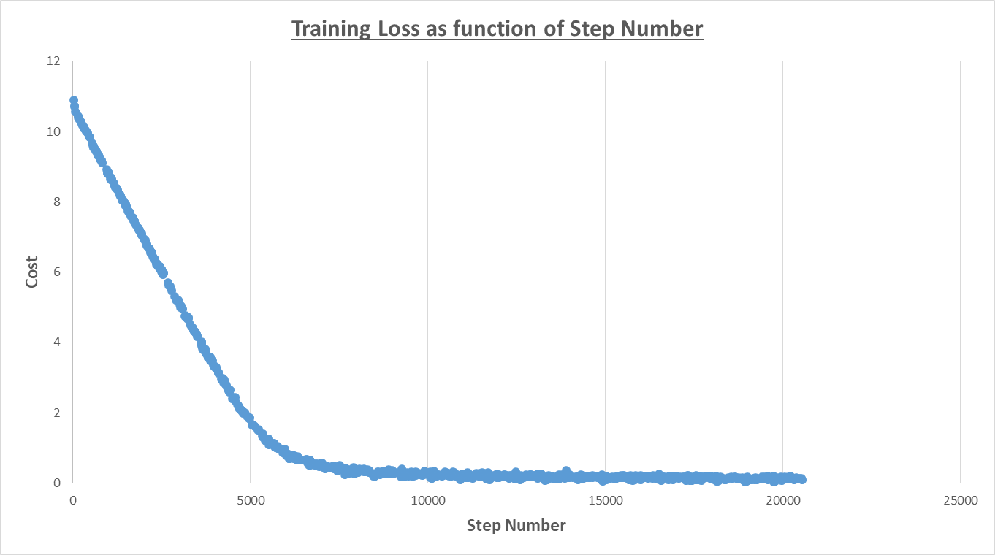

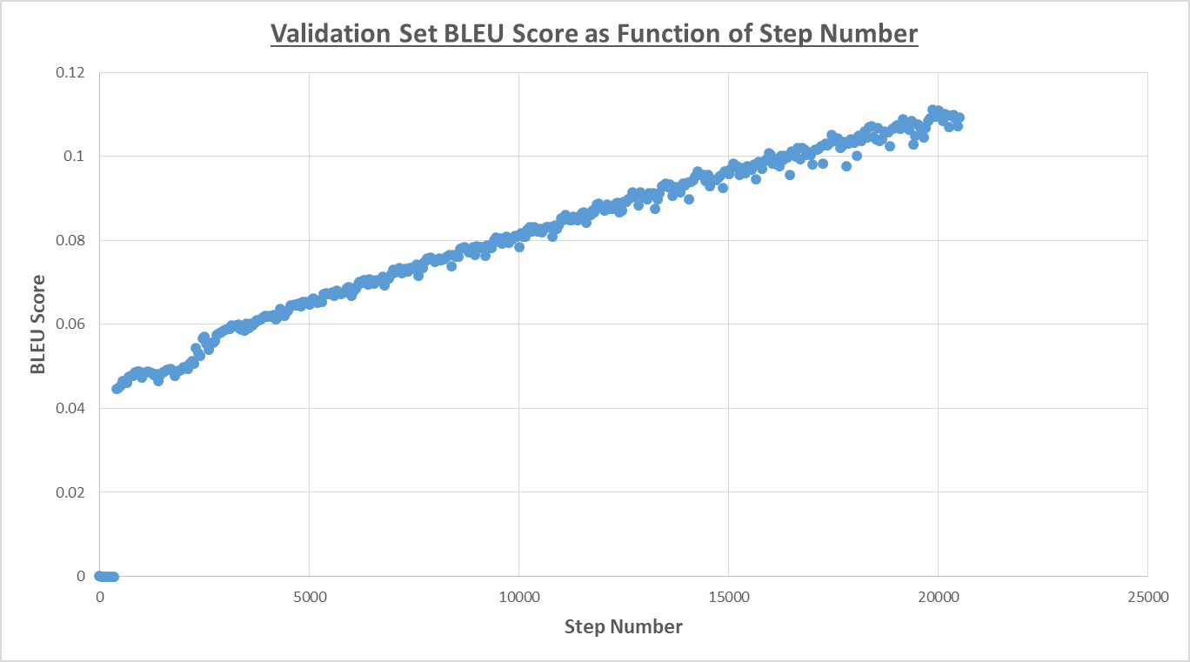

* **Test Set Translation Examples:**

|  |  |  |
| --- | --- | --- |
| **Original Sentence** | **Our Model Translation** | **True Translation** |
| how far does this go ? | כמה זה לעשות ? ? | כמה רחוק זה מגיע ? |
| layla is love for fadil was starting to become an obsession . | כל היה דבר היא היא מכלבים לבן . | האהבה של לילה לפדיל התחילה להיות כפייתית . |
| did you know there was a secret passage hidden behind the bookcase ? | האם עדיין פעם דולר על החיות ? שלי | ידעת שיש מעבר סודי מאחורי כוננית הספרים ? |
| a woman is virtue is everything . | ציפור שייך מזה זה . . | סגולת האשה היא חזות הכל . |
| i started screaming . | התחלתי לצעוק . | התחלתי לצרוח . |
| tom just could not resist teasing mary about the way she was dressed . | תום לא לא הצליח לתת להתעלם ממרי מרי כדי את מרי . מרי . . | תום פשוט לא יכול היה לעמוד בפני הפיתוי להקניט את מרי על אופן לבושה . |
| tomorrow it will be too late . | מחר זה יהיה גדול מדי . | מחר זה יהיה מאוחר מדיי |

## **Results analysis:**

In general, our model did not perform very well, as the maximum BLEU score for a sentence in the test set was *0.643*, which compared to the original article is very low. This is relatively expected, as we had significantly less data. Moreover, the differences between Hebrew and English makes the translation harder. Differences such as the sentences words orders when adjectives are in the sentence, gender of verbs, one to many translations etc. Another thing that might help with the poor performance was the use of multiple Hebrew translations to the same English sentence.

We thought that our model might have better results for shorter sentences, but that wasn’t the case. This might be because of differences between the languages – a short sentence in English can be long in Hebrew and vice versa. Secondly, even though English’s origin is German, and French is a Latin language, it is known that English was highly influenced by Latin [1] and thus have some basic similarities that English and Hebrew don’t.

## **Conclusions:**

Despite the relatively low results, we believe that this model was able to capture some of the connections between the languages, as seen in the translation examples above, and simply didn’t have enough data to learn from.

As stated above, there were 2 main aspects that we hypothesize that gave as these results – the size of the data set and the use of Hebrew as a target language instead of French. We believe that training on more data and tweaking the model (perhaps don’t reverse the input) will retain better results. We also believe that choosing a better dataset, that is gender consistent and without multiple translations to the same sentence.

## **References:**

1. Baugh, A.C. and T. Cable, *A history of the English language*. 1993: Routledge.

**נשאר לעשות:**

* לעבור על הדו"ח שוב
* לכתוב הערות על הקוד
* לכתוב readMe על איך משתמשים בקוד (ראה הוראות)